10.10.26 - Separate Tour Programme for Spouses

OPTION 1: MORNING TOUR | 08:00 – 12:00
08:00 – Pick-up
HoaBinhTourist’s vehicle and professional English-speaking tour guide will pick up guests at their hotel or a designated meeting point in central Da Nang.
Son Tra Peninsula
Proceed to Son Tra Peninsula, known as the “green lung” of Da Nang. Visit Linh Ung Pagoda, home to the iconic 67-metre-high Lady Buddha (Guanyin) Statue, one of the tallest Buddhist statues in Vietnam. Enjoy spectacular panoramic views overlooking Da Nang City, My Khe Beach, and Da Nang Bay.
Marble Mountains
Continue to Marble Mountains, a renowned cultural and spiritual landmark featuring dramatic limestone caves, ancient pagodas, and Buddhist shrines. Explore Huyen Khong Cave, Linh Ung Pagoda, and Vong Hai Dai (Ocean View Tower), while discovering the centuries-old tradition of stone carving at Non Nuoc Stone Carving Village.
Museum of Cham Sculpture
Continue the sightseeing programme with a visit to the Museum of Cham Sculpture, which houses Vietnam’s most extensive collection of Cham artefacts and sculptures. The collection features hundreds of works dating from the 5th to the 15th centuries, offering an insight into the rich cultural heritage and artistic achievements of the ancient Champa civilization.
12:00 – Return Transfer
Transfer guests back to their hotel or the original pick-up point.
End of the half-day Da Nang City Tour.

OPTION 2: AFTERNOON TOUR | 14:00 – 16:30
14:00 – Pick-up
HoaBinhTourist’s vehicle and professional English-speaking tour guide will pick up guests at their hotel or a designated meeting point.
Museum of Cham Sculpture
Begin the tour with a visit to the Museum of Cham Sculpture, home to more than 400 valuable artefacts showcasing the distinctive art, history, and cultural heritage of the ancient Champa civilization. The museum offers an enriching introduction to Vietnam’s fascinating Cham cultural legacy.
Marble Mountains
Continue to Marble Mountains, a spectacular natural and spiritual landmark renowned for its mysterious caves, ancient pagodas, and sacred Buddhist sites. Explore the mountain complex and enjoy panoramic views over the coastline and Da Nang. Guests will also have free time to browse and purchase traditional fine-art stone products at Non Nuoc Stone Carving Village.
Son Tra Peninsula
Proceed to Son Tra Peninsula and visit Linh Ung Pagoda, home to the iconic 67-metre-high Lady Buddha (Guanyin) Statue. Take in the fresh sea breeze and enjoy the scenic coastal surroundings, with an opportunity to admire the beautiful sunset over Da Nang Bay.
16:30 – Return Transfer
Transfer guests back to their hotel or the designated meeting point.
End of the half-day Da Nang City Tour.

11.10.26 - Delegation Tour
(anh tạo map giúp em đi từ furama bà nà theo đúng tuyến đường này
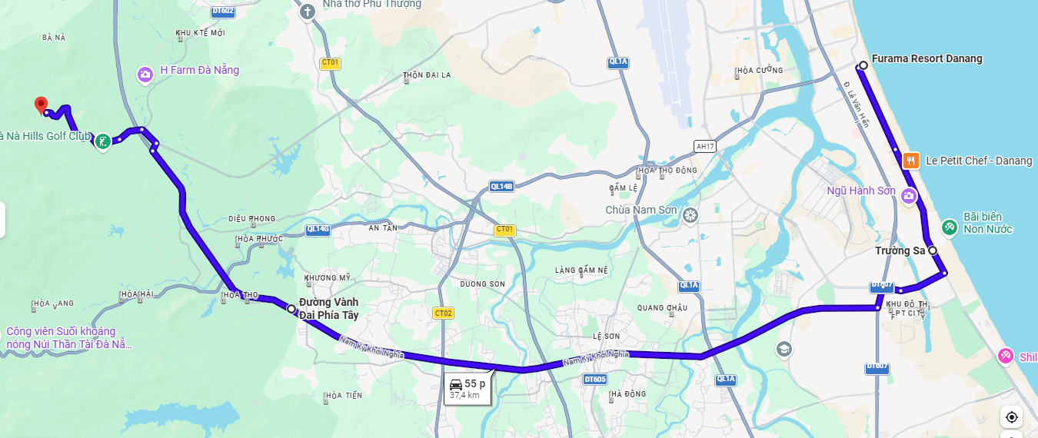
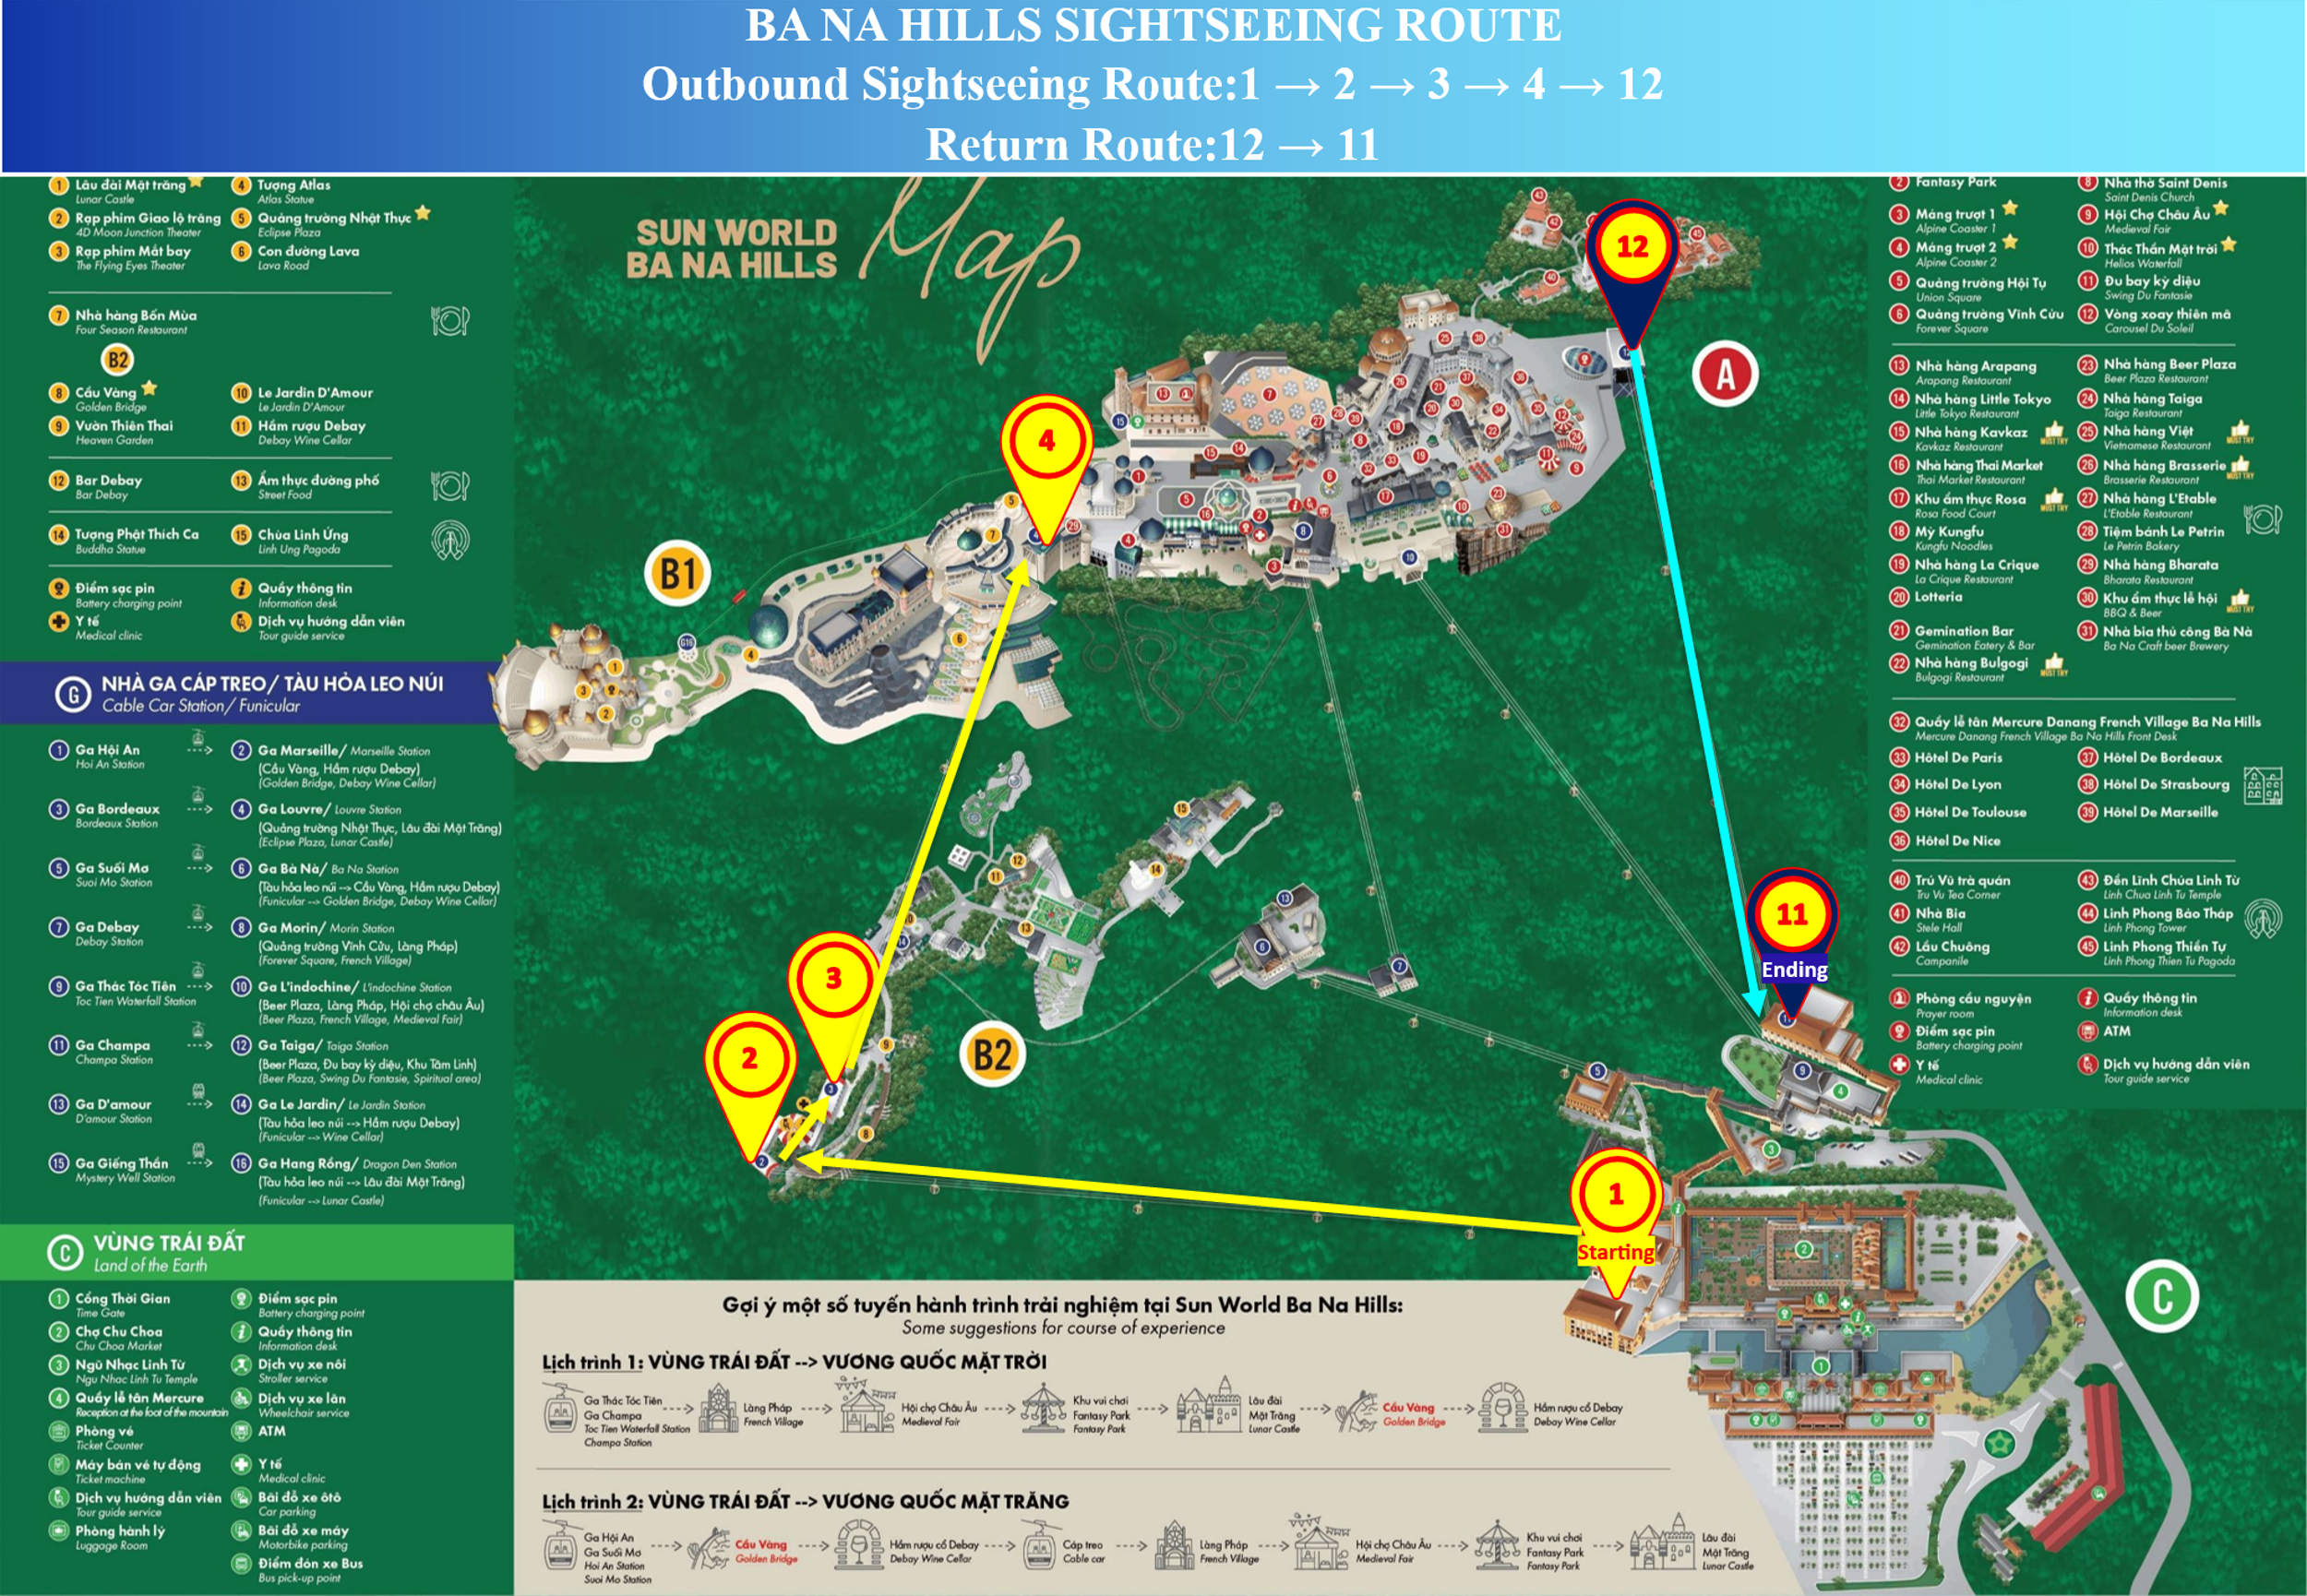
BA NA HILLS SIGHTSEEING ITINERARY
NOTE:
Delegates are kindly requested to bring and present their delegate badges in order to access the priority services and privileges available at Ba Na Hills.

ACTIVITY | TIME | ITINERARY / DESCRIPTION | LOCATION
TRANSFER TO BA NA HILLS | 08:00 – 09:00 | Depart from Da Nang City Centre and transfer to Sun World Ba Na Hills. | Da Nang City
WELCOME & CABLE CAR TRANSFER | 09:00 – 09:30 | Welcome the delegates and proceed by Cable Car Line No. 04 to the sightseeing area. | Thoi Gian Gate – Hoi An Station 1 – Marseille
VISIT ICONIC LANDMARKS | 09:30 – 10:45 | Visit and take commemorative photos at the Golden Bridge, one of the world-renowned bridges, followed by a visit to Le Jardin d’Amour Flower Garden. | Golden Bridge – Flower Garden
EXPLORE THE KINGDOM OF THE SUN | 10:45 – 11:45 | Take Cable Car Line No. 05 to explore Vinh Cuu Square and the Spiritual Area, while enjoying panoramic views of Ba Na Hills from an elevation of 1,487 metres above sea level. | Vinh Cuu Square – Spiritual Area
LUNCH / CULINARY EXPERIENCE | 11:45 – 13:30 | Enjoy lunch and a culinary experience at 1901 Restaurant. | 1901 Restaurant – Ba Na Brew House
LEISURE & ENTERTAINMENT | 13:30 – 15:00 | Explore French Village, experience the European Fair, and enjoy entertainment at Fantasy Park. | French Village – Fantasy Park
END OF ITINERARY | 15:00 – 15:30 | Conclude the sightseeing programme and take Cable Car Line No. 03 back to Da Nang City. | Cable Car Line No. 03

